**SOURCE CODE -**

<!DOCTYPE html>

<html lang="en">

<head>

    <meta charset="UTF-8">

    <meta http-equiv="X-UA-Compatible" content="IE=edge">

    <meta name="viewport" content="width=device-width, initial-scale=1.0">

    <title>Final Project</title>

    <link rel="stylesheet" href="style.css">

    <link rel="stylesheet" href="https://maxcdn.bootstrapcdn.com/bootstrap/3.4.1/css/bootstrap.min.css">

    <script src="https://ajax.googleapis.com/ajax/libs/jquery/3.6.0/jquery.min.js"></script>

    <script src="https://maxcdn.bootstrapcdn.com/bootstrap/3.4.1/js/bootstrap.min.js"></script>

    <link href="https://fonts.googleapis.com/css2?family=IBM+Plex+Serif:ital,wght@1,700&family=Oswald&display=swap" rel="stylesheet">

    <link rel="stylesheet" href="popupMessage.html">

</head>

<body>

    <nav class="navbar" id="navLinks">

        <div class="info">

            <ul>

                <img src="./images/logo 2.png" alt="Loading...">

                <li> <a href="#"></a>Home</li>

                <li> <a href="aboutUs.html"></a>About us</li>

                <li> <a href="services.html"></a>Services</li>

                <li > <a onclick="popupMessage.html" href="register.html"></a>Register</li>

                <li> <a href="contactUs.html"></a>Contact us</li>

                  <input type="text" id="find" placeholder="Find Hospitals,locations,doctors,...">

                  <button class="call">Contact us</button>

            </ul>

        </div>

    </nav>

    <!-- <div class="image">

        <img src="./images/img1.png" alt="">

        <fieldset class="content">

            <legend>hospital name</legend>

            <p>Lorem ipsum dolor sit amet consectetur, adipisicing elit. Illo officiis, sed doloribus laudantium, minima, harum veniam voluptates veritatis enim itaque dolor. Dolore modi eligendi quisquam ex quidem eos fugit libero?</p>

        </fieldset>

    </div> -->

    <div class="container">

        <br>

        <div id="myCarousel" class="carousel slide" data-ride="carousel">

          <ol class="carousel-indicators">

            <li data-target="#myCarousel" data-slide-to="0" class="active"></li>

            <li data-target="#myCarousel" data-slide-to="1"></li>

            <li data-target="#myCarousel" data-slide-to="2"></li>

            <li data-target="#myCarousel" data-slide-to="3"></li>

          </ol>

          <div class="carousel-inner" role="listbox">

            <div class="item active" id="img1">

              <img src="./images/img1.png" alt="Chania" width="460" height="345">

              <div class="carousel-caption">

              </div>

            </div>

            <div class="item" id="img2">

              <img src="./images/img5.jpg" alt="Chania" width="460" height="345">

              <div class="carousel-caption">

              </div>

            </div>

            <div class="item" id="img3">

              <img src="./images/img2.webp" alt="Flower" width="460" height="345">

              <div class="carousel-caption">

              </div>

            </div>

            <div class="item" id="img4">

              <img src="./images/img3.webp" alt="Flower" width="460" height="345">

              <div class="carousel-caption">

              </div>

            </div>

          </div>

          <a class="left carousel-control" href="#myCarousel" role="button" data-slide="prev">

            <span class="glyphicon glyphicon-chevron-left" aria-hidden="true"></span>

            <span class="sr-only">Previous</span>

          </a>

          <a class="right carousel-control" href="#myCarousel" role="button" data-slide="next">

            <span class="glyphicon glyphicon-chevron-right" aria-hidden="true"></span>

            <span class="sr-only">Next</span>

          </a>

        </div>

      </div>

      <nav class="navbar2">

        <div class="options">

            <ul>

                <li id="option1"> <a href="#"></a>Book an Appointment</li>

                <li id="option2" > <a href="#"></a>Consult Online</li>

                <li id="option3"> <a href="#"></a>Buy Medicine</li>

                <li id="option4"> <a href="#"></a>Find Hospital</li>

                <li id="option5"> <a href="#"></a>Emergency</li>

            </ul>

        </div>

    </nav>

    <div class="covid">

          <p id="main">COVID-19 Information !

          </p>

    </div>

    <div class="aboutUs">

          <h3>About Us</h3> <br>

          <p>

            Largest network of the world's <br> finest and brightest medical <br> experts who provide compassionate care using <br> outstanding expertise and advanced technology. <br> Leveraging its vast medical expertise <br> & technological advantage, Our hospital has <br> consistently delivered best in class clinical outcomes.</p>

        <span id="">

          <img style="float:right; max-height: 400px; margin-right: 42px; margin-top: -299px; margin-left: 153px; height: 700px; width: 700px;"src="./images/aboutUS.jpg" alt="Loading..">

      </span>

    </div>

    <div class="wavy">

      <span style="--i:1">A</span>

      <span style="--i:2">C</span>

      <span style="--i:3">H</span>

      <span style="--i:4">I</span>

      <span style="--i:5">E</span>

      <span style="--i:6">V</span>

      <span style="--i:7">M</span>

      <span style="--i:8">E</span>

      <span style="--i:9">N</span>

      <span style="--i:10">T</span>

      <span style="--i:11">S</span>

     </div>

    <nav class="navbar3">

      <div class="facilities">

          <ul>

              <li id="facility1"> <a href="#"></a>

                <img src="./images/cancer-surgeries.webp" alt="Cancer Surgeries" width="40px" height="80px">

              <h2>12,342+</h2>

            <p>Complex <br> Cancer Surgeries </p>

          </li>

              <li id="facility2" > <a href="#"></a>

              <img src="./images/robotic-surgeries.webp" alt="Robotic Surgeries" width="40px" height="80px">

            <h2>410+</h2>

          <p>Doctors from all <br>Departments </p>

        </li>

              <li id="facility3"> <a href="#"></a>

                <img src="./images/liver-transplants.webp" alt="Liver Transplant" width="40px" height="80px">

                <h2>211+</h2>

                <p>Liver Transplants</p>

              </li>

              <li id="facility4"> <a href="#"></a>

              <img src="./images/docter-department.webp" alt="Doctor-department" width="40px" height="80px">

              <h2>1776+</h2>

              <p>Robotic Surgeries</p>

            </li>

          </ul>

      </div>

  </nav>

  <div class="services">

    <h2>Services</h2>

  <span>

  <div class="col-lg-4 col-md-6 col-sm-6 col-12">

    <div class="departments-box-layout1">

        <div class="box-content">

            <i class="flaticon-anesthesia"></i>

            <h3 class="item-title">

                <a href="DepartmentDetail/Anesthesia">Anesthesia</a>

            </h3>

            <p>

                We provide a comprehensive range of clinical services, including peri-operative anaesthesia services, neuro-anaesthesia and organ transplant anaesthesia. The Department of Anaesthesiology of the hospital has achieved excellence for general and regional anaesthesia.

            </p>

        </div>

    </div>

</div>

<div class="col-lg-4 col-md-6 col-sm-6 col-12">

  <div class="departments-box-layout2">

      <div class="box-content">

          <i class="flaticon-emergency-sign"></i>

          <h3 class="item-title">

              <a href="DepartmentDetail/Emergency-Trauma">Emergency &amp; Trauma center</a>

          </h3>

          <p>

              Our Hospital is a pioneer of modern-day emergency care in entire district and operates one of the best Accident &amp; Emergency Centre in South-Gujarat, providing services for trauma and non-trauma medical and surgical emergencies 24 hours a day

          </p>

      </div>

  </div>

</div>

<div class="col-lg-4 col-md-6 col-sm-6 col-12">

  <div class="departments-box-layout3">

      <div class="box-content">

          <i class="flaticon-pathology"></i>

          <h3 class="item-title">

              <a href="DepartmentDetail/Clinical-Pathology">Clinical Pathology</a>

          </h3>

          <p>

              Laboratories Services at our Hospital Headed by Doctors have been established with a view to provide wide range of Laboratory investigations necessary for patient care.

          </p>

      </div>

  </div>

</div>

<div class="col-lg-4 col-md-6 col-sm-6 col-12">

  <div class="departments-box-layout4">

      <div class="box-content">

          <i class="flaticon-pills"></i>

          <h3 class="item-title">

              <a href="DepartmentDetail/General-Internal-Medicine">General Internal Medicine</a>

          </h3>

          <p>

              Kasturba Hospital, Valsad offers high quality care and treatment for various medical illnesses and infectious diseases. The department of Internal Medicine at Kasturba Hospital is a group of specialist doctors and allied health staff who are dedicated

          </p>

      </div>

  </div>

</div>

<div class="col-lg-4 col-md-6 col-sm-6 col-12">

  <div class="departments-box-layout5">

      <div class="box-content">

          <i class="flaticon-gynecology"></i>

          <h3 class="item-title">

              <a href="DepartmentDetail/Obstetric-Gynecology">Obstetric Gynecology</a>

          </h3>

          <p>

              Being pregnant is indeed a wonderful experience and most pregnant mothers want to have the best possible care for themselves and their babies. Department of Obstetrics &amp; Gynaecology at Kasturba Hospital, vlasad is committed to give the highest standard of care

          </p>

      </div>

  </div>

</div>

<div class="col-lg-4 col-md-6 col-sm-6 col-12">

  <div class="departments-box-layout6">

      <div class="box-content">

          <i class="flaticon-eye"></i>

          <h3 class="item-title">

              <a href="DepartmentDetail/Ophthalmology">Ophthalmology</a>

          </h3>

          <p>

              Headed by Dr. Pritesh Desai, who undergone training from a prestigeous institute, Mumbai is taking care of this department. He is well versed with implanting Foldable Lenses and performs various other surgeries including Glaucoma Pterygium, Dacryocystorhinostomy (DCR), Eye Lid Surgeries and Ocular Trauma Cases.

          </p>

      </div>

  </div>

</div>

</span>

</div>

<div class="form">

  <h3>Registration form</h3> <br>

  Full name :

  <input type="text" name="" id=""><br><br>

  Email :

  <input type="email" name="" id=""> <br><br>

  Contact :

  <input type="number" name="" id=""> <br><br>

  Password :

  <input type="text" name="" id="" placeholder="minimum 8 characters"><br><br>

  <button id="submit">Submit</button>

</div>

<footer>

  <div class="contactus">

    <span>

      <h2>Contact Us</h2>

      <p>Follow Us on Social Media</p>

      <p id="last">Privacy Policy | Disclaimer | Contact | Sitemap</p>

      <p id="copyright">© 2022 CARE & CURE  Hospitals Enterprise Ltd. All Rights Reserved</p>

      <p id="groupmembers">Aarushi Jadhav - TCRIA6R19  <br>

       Kamakshi Arya somayajula - TCRIA6R21 <br>

      Sushmitha Poojari - TCRIA6R22</p>

    </span>

  </div>

  </footer>

</body>

</html>

**CSS :**

*{

    box-sizing: border-box;

}

body{

    background-image: url("https://media.istockphoto.com/vectors/abstract-geometric-medical-cross-shape-medicine-and-science-concept-vector-id940993008?k=20&m=940993008&s=612x612&w=0&h=rCRrrtzkm7aUqbzFf_ov3KF5UWgc_yDu_GAibzmVbWE=");

    background-repeat: no-repeat;

    background-size: cover;

}

.info ul {

    text-decoration: none;

    overflow: auto;

    list-style: none;

    padding: 3px;

    margin: 2px;

    text-align: center;

    cursor: pointer;

}

.info li {

    float: left;

    padding-top: 0px;

    margin: 3px;

    font-size: 26px;

}

.info ul :hover{

    color: red;

}

.info a {

    color: black;

    font-family: cursive;

    font-size: 25px;

    padding: 1px 22px;

    /* margin: 5px 1px; */

    text-align: center;

    text-decoration: none;

}

.info img {

    float: left;

    width: 124px;

    height: 100px;

    padding: 1px;

    /* margin: -18px 3px; */

    margin-top: -25px;

}

.container{

    margin-top: -40px;

}

#find{

    height: 25px;

    width: 300px;

    margin: 12px;

}

.call{

    border-radius: 4px;

}

.carousel-inner {

    height: 450px;

    width: 1200px;

}

#img1 img {

    height: 450px;

    width: 1200px;

}

#img2 img {

    height: 450px;

    width: 1200px;

}

#img3 img {

    height: 450px;

    width: 1200px;

}

#img4 img {

    height: 450px;

    width: 1200px;

}

.navbar2{

    margin: 28px;

    margin-top: 55px;

    border: 2px solid black;

    background-color: rgb(0, 0, 128);

    color: white;

}

.options ul {

    text-decoration: none;

    overflow: auto;

    list-style: none;

    padding: 3px;

    margin: 2px;

    text-align: center;

}

.options li {

    float: left;

    padding-top: 20px;

    padding-bottom: 20px;

    margin: 3px;

    font-size: 26px;

    display: flex;

}

#option1{

    border: 2px solid darkblue;

    padding: 32px;

    margin-left: 37px;

}

.options ul :hover{

    color: white;

    background-color: black;

    border-radius: 30px;

}

#option2{

    border: 2px solid darkblue;

    padding: 32px;

}

#option3{

    border: 2px solid darkblue;

    padding: 32px;

}

#option4{

    border: 2px solid darkblue;

    padding: 32px;

}

#option5{

    border: 2px solid darkblue;

    padding: 32px;

}

/* #main {

    background-color: yellow;

    color: black;

    height: 100px;

    font-family: 'Oswald', sans-serif;

    font-size: 20px;

    text-align: center;

    margin-top: 4px;

} */

#main{

   text-transform: uppercase;

  background-image: linear-gradient(

    -225deg,

    #231557 0%,

    #44107a 29%,

    #ff1361 67%,

    #fff800 100%

  );

  background-size: auto auto;

  background-clip: border-box;

  background-size: 200% auto;

  color: #fff;

  background-clip: text;

  text-emphasis-color: transparent;

  -webkit-background-clip: text;

  -webkit-text-fill-color: transparent;

  animation: textclip 2s linear infinite;

  display: inline-block;

      font-size: 50px;

      margin-top: 5px;

      margin-left: 369px;

}

@keyframes textclip {

  to {

    background-position: 200% center;

  }

}

.aboutUs {

    background-color: rgb(255, 184, 53);

    color: black;

    float: left;

    position: relative;

    display: flex;

    display: inline;

    padding-top: 30px;

    padding-bottom: 120px;

    padding-left: 20px;

}

.aboutUs p {

    position: relative;

    display: inline;

    margin-block-start: 1em;

    margin-block-end: 1em;

    margin-inline-start: 0px;

    margin-inline-end: 0px;

    font-size: 25px;

}

.aboutUs h3 {

    margin-top: 26px;

    font-family: 'Oswald', sans-serif;

    font-size: 60px;

}

/* .services{

    background-color: #664ebd;

    margin-top: 50px;

}

.services h2 {

    font-family: 'Oswald', sans-serif;

    font-size: 40px;

    margin-top: 50px;

}

.services p{

    position: relative;

    display: inline;

    margin-block-start: 1em;

    margin-block-end: 1em;

    margin-inline-start: 0px;

    margin-inline-end: 0px;

    font-size: 25px;

} */

.navbar3{

    margin-top: 10px;

    background-color: #231557;

    color: #88f8ff;

}

.facilities li {

    display: inline-block;

    width: 24%;

    text-align: center;

    vertical-align: top;

    position: relative;

    margin-top: 20px;

    font-size: 28px;

}

.facilities li h2 {

    font-size: 40px;

}

.facilities li h2 {

    color: #88f8ff;

    font-size: 42px;

    font-weight: bold;

    text-shadow: 1px 1px 2px #000;

}

h2 {

    font-size: 40px;

    line-height: normal;

    margin: 20px 0;

}

.facilities ul :hover {

    animation:forwards;

    animation-timing-function: 3s;

    animation-fill-mode: forwards;

}

.wavy {

   text-align: center;

  position: relative;

  /* -webkit-box-reflect: below -20px linear-gradient(transparent, rgba(0,0,0,.2)); */

  font-size: 60px;

}

.wavy span {

  font-family: 'Alfa Slab One', cursive;

  position: relative;

  display: inline-block;

  color: black;

  text-transform: uppercase;

  animation: wavy 1s infinite;

  animation-delay: calc(.1s * var(--i));

}

@keyframes wavy {

  0%,40%,100% {

    transform: translateY(0)

  }

  20% {

    transform: translateY(-20px)

  }

}

.departments-box-layout1 {

    /* position: relative; */

    /* width: 100%; */

    margin-bottom: 10px;

    padding: 53px 35px;

    border-radius: 4px;

    background-color: #ffffff;

}

.departments-box-layout2 {

    /* position: relative; */

    /* width: 100%; */

    margin-bottom: 10px;

    padding: 63px 35px;

    border-radius: 4px;

    background-color: #ffffff;

}

.departments-box-layout3 {

    /* position: relative; */

    /* width: 100%; */

    margin-bottom: 10px;

    padding: 72px 35px;

    border-radius: 4px;

    background-color: #ffffff;

}

.departments-box-layout4 {

    /* position: relative; */

    /* width: 100%; */

    margin-top: 2px;

    margin-bottom: 10px;

    padding: 53px 35px;

    border-radius: 4px;

    background-color: #ffffff;

}

.departments-box-layout5{

    margin-top: -275px;

    margin-bottom: 100px;

    padding: 53px 35px;

    border-radius: 4px;

    background-color: #ffffff;

}

.departments-box-layout6{

    margin-top: -275px;

    margin-bottom: 100px;

    padding: 41px 35px;

    border-radius: 4px;

    background-color: #ffffff;

}

.services h2 {

    margin-left: 20px;

    font-family: 'Oswald', sans-serif;

    font-size: 60px;

    color: black;

    text-align: center;

}

.contactus{

    padding-top: 100px;

    background-color: black;

    color: white;

    text-align: center;

}

#last{

    text-align: center;

    margin: 60px;

}

#groupmembers{

    margin-top: 10px;

    text-align: center;

    padding-bottom: 30px;

}

.form{

    font-size: medium;

    margin-top: 700px;

    margin-left: 365px;

    margin-bottom: 100px;

    height: 300px;

    width: 600px;

    padding: 50px;

    padding-left: 22px;

    padding-bottom: 353px;

    border: 2px solid black;

    background-color: pink;

    border-radius: 10px;

}

.form h3{

    text-align: center;

}

#submit{

    align-items: center;

    margin-left: 231px;

    margin-top: 3px;

}

**JAVASCRIPT:**

// navbar togglemenu start

var navLinks = document.getElementById("navLinks");

function showMenu(){

    navLinks.style.right = "0";

}

function hideMenu(){

    navLinks.style.right = "-200px";

}

// navbar togglemenu end

**OUTPUT :**

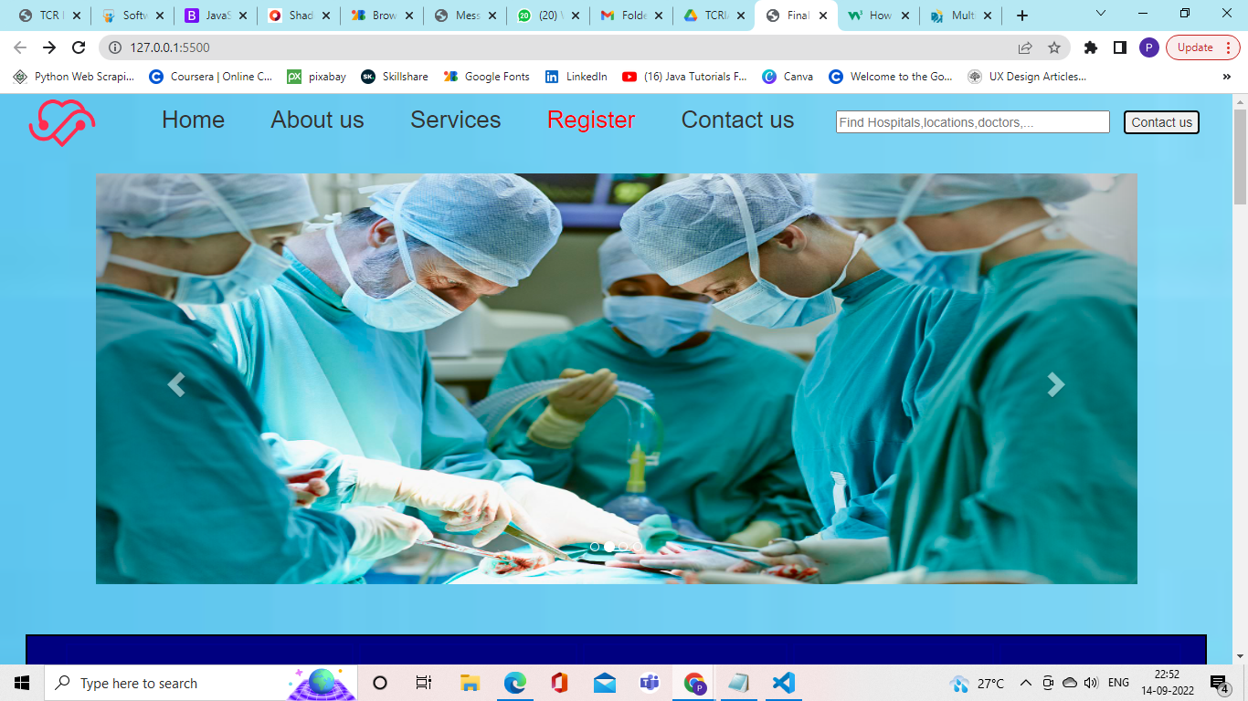

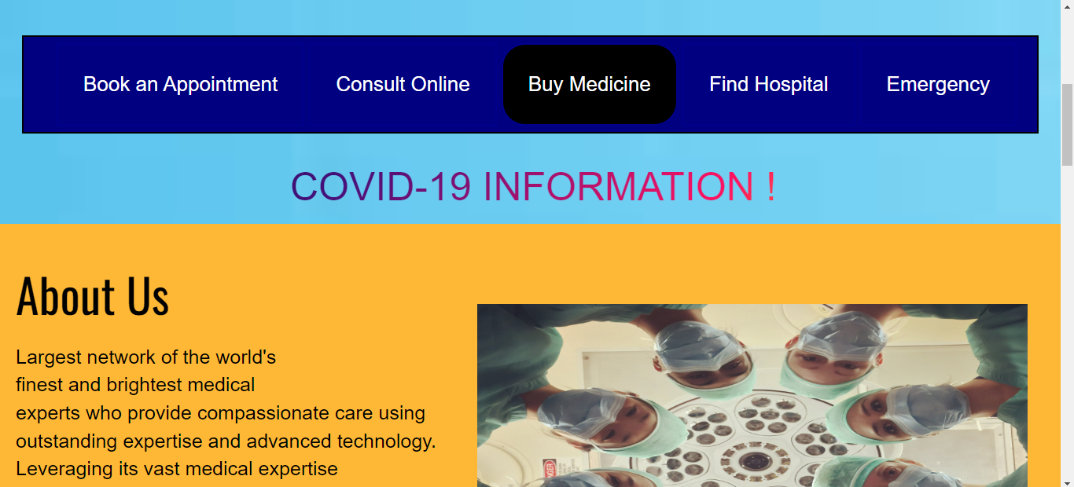

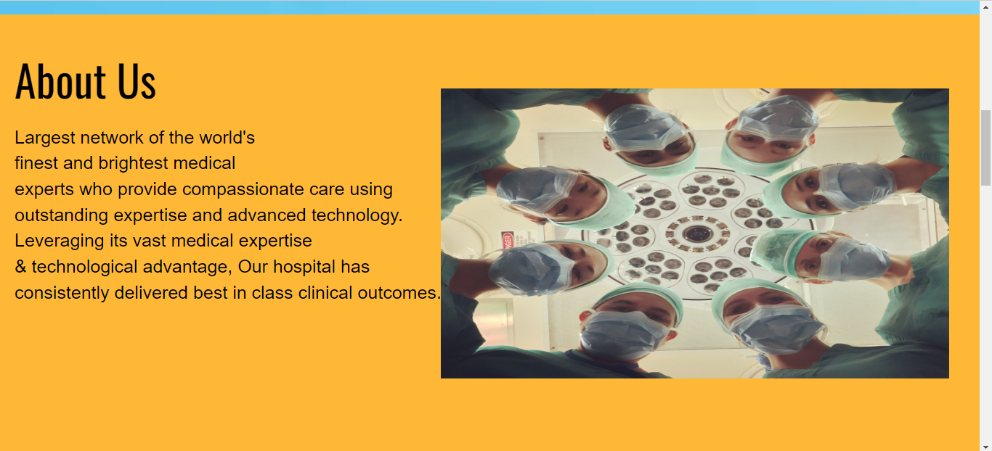

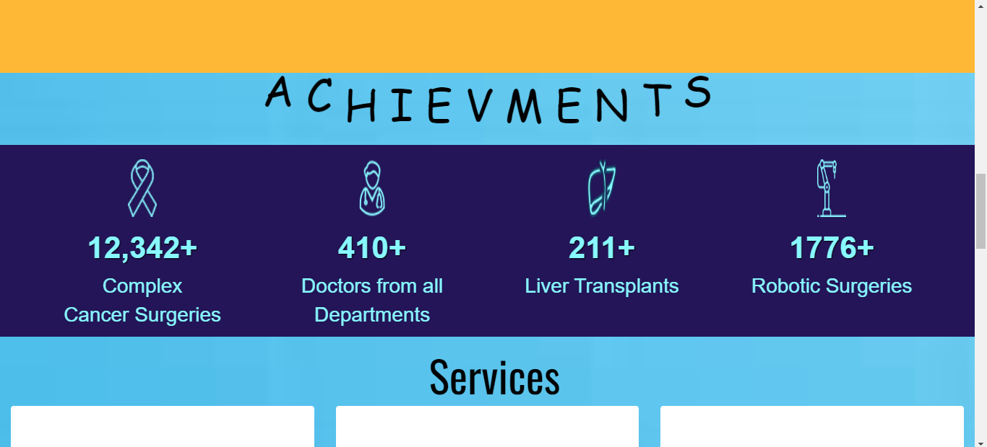

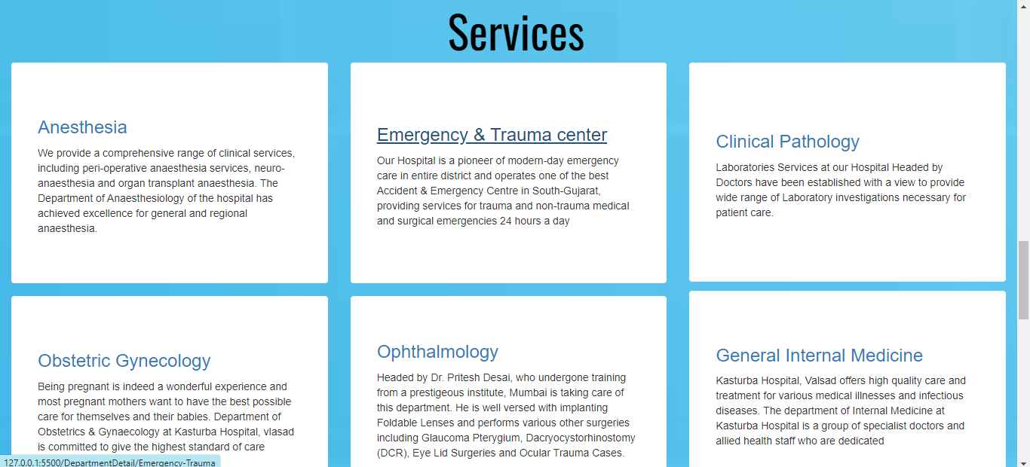

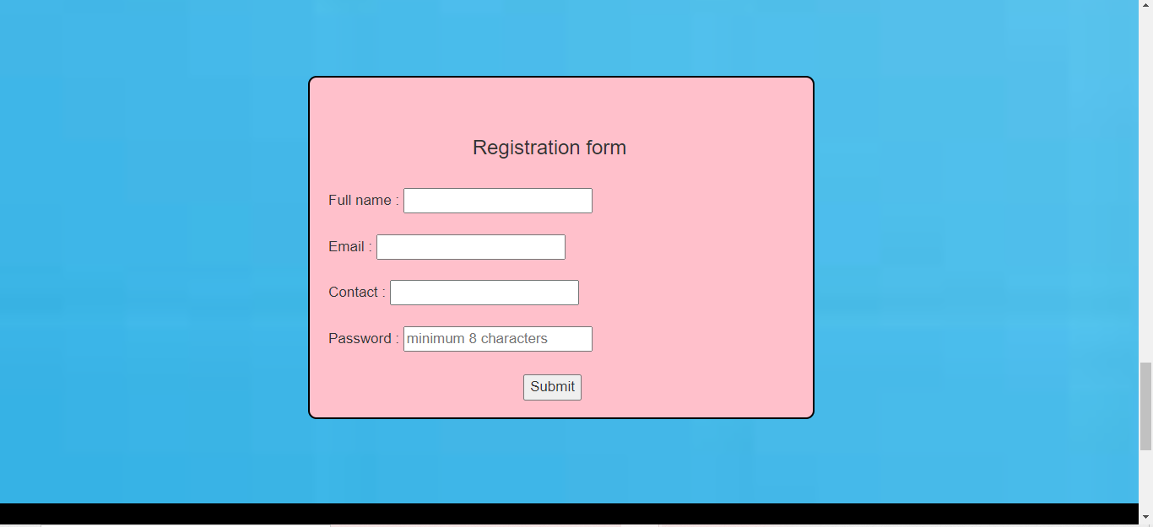

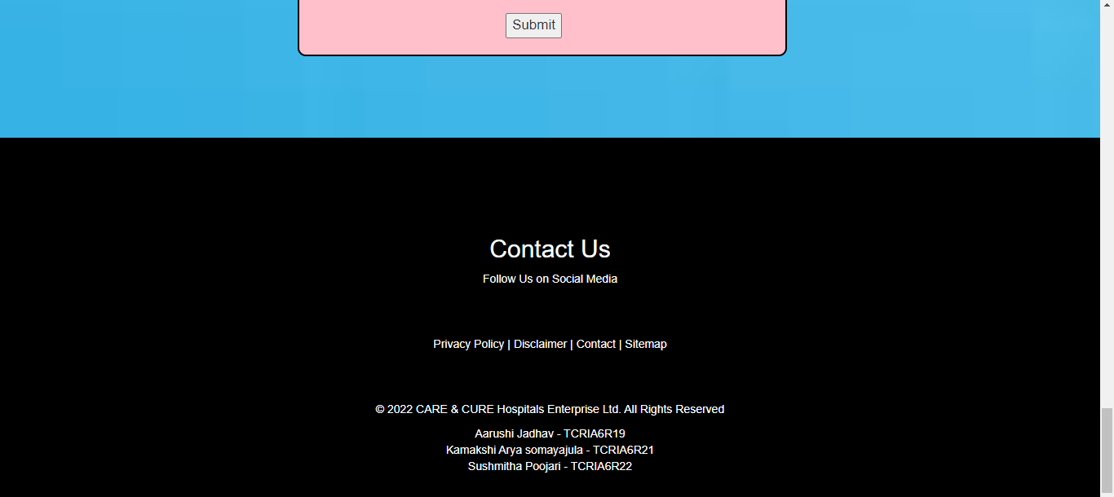

**PROJECT BY :**

**AARUSHI JADHAV (TCRIA6R19)**

**KAMAKSHI ARYA SOMAYAJULA (TCRIA6R21)**

**SUSHMITHA POOJARI (TCRIA6R22)**